**Splitting the Data in X and Y:**

df.head()

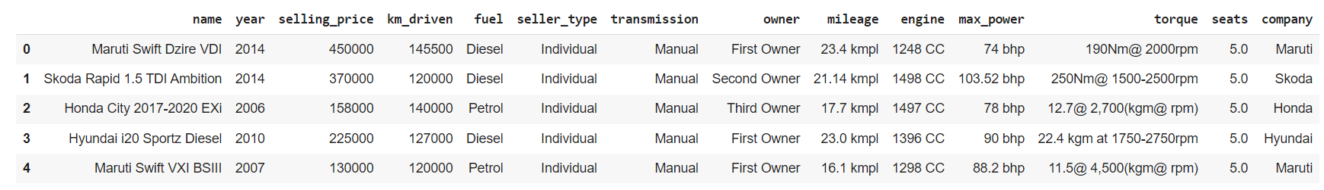

X = df.drop(columns = ["selling_price"])

Y = df["selling_price"]

X_train, X_test, Y_train, Y_test = train_test_split(X, Y, train_size = 0.75, random_state = 32)

print(X_train.shape)

print(X_test.shape)

print(Y_train.shape)

print(Y_test.shape)

